SeShop - Architecture Design Document (ADD)
Field | Value
Project | SeShop
Domain | Omnichannel clothing and accessories platform
Document Type | Architecture Design Document
Template Source | Template/ADD.docx
Version | 1.1
Date | 2026-05-07

Revision History
Date | Version | Author | Description
2026-04-30 | 1.0 | Architecture Team | Initial ADD using iterative decomposition from ASR
2026-05-07 | 1.1 | Architecture Team | Reformatted to match ADD.docx structure: design constraints, quality attribute requirements, and architectural representation

Table of Contents
- Design Constraints
- Quality Attribute Requirements
  - Security
  - Performance
  - Usability
  - Interoperability
  - Modifiability
  - Availability
- Architectural Representation
  - Logical View
  - Implementation View
  - Deployment View
  - Data View

1. Design Constraints
The following constraints define the allowed architecture space for SeShop. They are derived from the BRD, SRS, ASR, API specification, and database schema.
- Architecture style: The backend is a modular monolith. Domain boundaries are enforced inside one deployable Spring Boot application instead of separate microservices.
- Backend technology: Java 21 and Spring Boot 3.3 are required.
- Frontend technology: React 18, TypeScript 5, and Vite are required.
- Database technology: PostgreSQL 15 is the transactional system of record.
- Cache technology: Redis may be used for hot catalog and availability reads, but it is not a source of truth.
- API style: External application communication uses REST/JSON over HTTPS under the /api/v1 namespace.
- Module boundaries: Backend modules are logically separated but may communicate through shared services or repositories within the monolith context. Strict isolation is not enforced.
- Stock consistency: Checkout, POS sale, refund, transfer, cycle count, goods receipt, and allocation operations must update stock inside a database transaction.
- Availability calculation: available_qty is computed as on_hand_qty - reserved_qty; it must not be stored as an independent column.
- Payment scope: Version 1 supports Stripe, Cash on Delivery, and in-store POS payment.
- Social publishing scope: Instagram support is compose-first. The system prepares and stores drafts but does not auto-publish without manual review.
- Auditability: Sensitive staff/admin and stock/money operations must create append-only audit records.
- Localization: Customer-facing and back-office interfaces must support Vietnamese and English text.
- Migration management: Database migrations are versioned and reviewed through Flyway-compatible scripts.

2. Quality Attribute Requirements
Each quality attribute requirement follows the ADD template format: stimulus, source, environment, artifact, response, and response measure.

2.1 Security

2.1.1 Authentication and Authorization
Element | Statement
Stimulus | A user signs in or invokes an API endpoint that requires authentication and permission checks.
Stimulus source | Customer, Authorized Staff, or Super Admin.
Environment | Normal web operation through the React SPA or direct API access.
Artifact | Spring Security layer, Identity & RBAC module, JWT/session handling, permission catalog.
Response | The system authenticates the user, computes effective permissions from assigned active roles, enforces server-side authorization, returns 403 FORBIDDEN for unauthorized actions, and records suspicious denied attempts.
Response measure | 100% of protected endpoints enforce authorization on the backend; unauthorized requests perform no side effects; permission checks add no more than 200 ms to normal request processing.

2.1.2 Data Protection
Element | Statement
Stimulus | Sensitive data is stored, transmitted, or used by an integration.
Stimulus source | Customers, staff users, payment gateway, Instagram OAuth flow, shipping provider, AI service.
Environment | Production runtime, backups, logs, and external API calls.
Artifact | PostgreSQL database, transport layer, external integration adapters, application logs.
Response | Passwords are stored as salted hashes; external tokens and secrets are encrypted at rest; all client and partner communication uses HTTPS/TLS; logs exclude plaintext secrets and payment tokens.
Response measure | Zero plaintext passwords or OAuth/payment secrets in database and logs; 100% external-facing endpoints require TLS; credential scan has no high-severity findings before release.

2.1.3 Auditability
Element | Statement
Stimulus | A sensitive operation changes access rights, stock, money, orders, refunds, POS shifts, invoices, Instagram connections, or audit-relevant configuration.
Stimulus source | Super Admin, Authorized Staff, or automated background process.
Environment | Normal business operation and compliance review.
Artifact | Audit subsystem and audit_logs table.
Response | The system creates an append-only audit record containing actor, action, target, timestamp, trace metadata, and before/after values when available.
Response measure | 100% coverage of sensitive operations; no application endpoint exposes audit UPDATE or DELETE behavior; audit records are searchable by actor, action, target, and date range.

2.2 Performance

2.2.1 Product Search and Browsing
Element | Statement
Stimulus | A customer searches, filters, sorts, or paginates the product catalog by category, size, color, price, or availability.
Stimulus source | Customer.
Environment | Normal daily load with concurrent browsing traffic.
Artifact | Catalog module, PostgreSQL indexes, optional Redis read-through cache, React storefront.
Response | The system returns a paginated product list with variant and availability information using indexed queries and cached hot reads where appropriate.
Response measure | 95th percentile response time is less than or equal to 2 seconds for normal product search and browse requests.

2.2.2 Inventory Mutation Latency
Element | Statement
Stimulus | Staff submits an inventory adjustment, transfer confirmation, POS stock decrement, checkout reservation, refund restock, cycle count posting, or goods receipt.
Stimulus source | Authorized Staff, Super Admin, Customer checkout, or background workflow.
Environment | Normal operations with concurrent stock-affecting actions.
Artifact | Inventory module, Commerce module, POS module, PostgreSQL inventory_balances table.
Response | The system validates the command, locks affected rows when required, commits the stock mutation atomically, and writes audit/domain-event records.
Response measure | Standard stock mutation commit latency is less than or equal to 500 ms; no stock mutation leaves partial state after failure.

2.2.3 Scalability for Locations and SKUs
Element | Statement
Stimulus | Business operations add new store/storage locations, product variants, or catalog categories.
Stimulus source | Authorized Staff or Super Admin.
Environment | Normal production operation without planned downtime.
Artifact | Catalog, Inventory, and PostgreSQL schema.
Response | New locations, SKUs, and category mappings are added as data records rather than schema changes. List endpoints remain paginated and indexed.
Response measure | Adding a location or SKU requires zero schema migrations; QAS product search and inventory latency targets remain satisfied after growth within expected v1 scale.

2.3 Usability

2.3.1 Staff Operational Workflow
Element | Statement
Stimulus | Trained staff perform routine POS, inventory, order fulfillment, refund, or social draft work.
Stimulus source | Authorized Staff.
Environment | Store or back-office workday with repeated task execution.
Artifact | Staff-facing React screens, API validation, workflow state models.
Response | The UI presents dense but scannable operational forms, immediate validation feedback, keyboard-friendly POS paths, and clear status transitions.
Response measure | A trained cashier can complete a 3-item POS sale in less than or equal to 60 seconds; common validation errors appear within 500 ms of field blur or submit.

2.3.2 Customer Checkout Experience
Element | Statement
Stimulus | A customer proceeds from cart to order confirmation.
Stimulus source | Customer.
Environment | Normal web use on desktop or mobile.
Artifact | Customer checkout UI, Commerce module, Payment adapter, Inventory reservation logic.
Response | The system guides the customer through shipping, discount, payment, and confirmation steps with no page reloads, clear error messages, and accurate stock/payment state.
Response measure | Checkout requires no more than 5 major steps; validation feedback appears within 500 ms; failed payment or insufficient stock produces no paid order.

2.4 Interoperability

2.4.1 Third-Party System Integration
Element | Statement
Stimulus | The platform sends requests to or receives callbacks from Stripe, shipping providers, Instagram, object storage, or an AI recommendation service.
Stimulus source | External service, customer checkout, staff workflow, or background job.
Environment | Normal operation and degraded partner availability.
Artifact | Infrastructure adapters, API clients, webhook/callback handlers.
Response | Integration calls use HTTPS, provider-specific authentication, bounded retries, timeouts, idempotency for money/stock effects, and clear error mapping into the API error model.
Response measure | External failure creates zero internal data corruption; users receive an actionable error within 5 seconds of timeout; provider swap changes are localized to adapter implementations.

2.4.2 Internal Module Communication
Element | Statement
Stimulus | One domain module requires data or side effects from another module, such as Commerce reserving stock or POS writing audit records.
Stimulus source | Backend application services and domain events.
Environment | Runtime inside the modular monolith.
Artifact | Application service interfaces, domain events, outbox/event dispatch mechanism.
Response | Synchronous in-process calls are used for command-critical results; asynchronous events are used for notifications, audit side effects, and eventual read updates. Modules do not bypass ownership by querying foreign tables directly.
Response measure | Cross-module business rule changes are limited to published interfaces/events; command-critical calls complete inside the request transaction when consistency is required.

2.5 Modifiability

2.5.1 Business Requirement Changes
Element | Statement
Stimulus | Product or operations stakeholders request a change to a business rule, such as discount policy, refund eligibility, stock allocation, or transfer approval.
Stimulus source | Business stakeholders and development team.
Environment | Development and maintenance.
Artifact | Backend domain modules, application services, React feature modules, API contract.
Response | The modular monolith confines the change to the relevant bounded context and its tests. Shared contracts are updated only when cross-module behavior must change.
Response measure | A single business rule change affects one primary backend module in the normal case; regression tests cover the changed module before release.

2.5.2 External Integration Replacement and Testability
Element | Statement
Stimulus | The team replaces a payment, shipping, Instagram, object storage, or AI provider, or needs to test domain behavior without real infrastructure.
Stimulus source | Business decision, vendor outage, QA/development team.
Environment | Development, CI, or production evolution.
Artifact | Ports and adapters, infrastructure clients, domain services, repository interfaces.
Response | Provider-specific logic is isolated behind adapter interfaces. Domain services depend on ports and can be tested with in-memory or mock implementations.
Response measure | Provider replacement requires zero domain-layer changes; domain/application test suites run without network access and without a shared test database.

2.6 Availability

2.6.1 Fault Tolerance and System Recovery
Element | Statement
Stimulus | An application instance, cache, external API, or non-primary component fails.
Stimulus source | Infrastructure fault, software defect, network issue, or partner outage.
Environment | Production runtime.
Artifact | Spring Boot API, PostgreSQL, Redis, object storage, external adapters, health probes, backups.
Response | Critical data remains in PostgreSQL; stateless API instances can be restarted or scaled; degraded integrations fail gracefully; health checks expose service status; backups support recovery.
Response measure | Core commerce target is 99.9% monthly availability; recovery procedures keep data loss within approved backup policy; Redis failure does not lose committed business state.

2.6.2 Automated Payment, Shipping, and Reservation Handling
Element | Statement
Stimulus | The system receives payment/shipping callbacks or detects expired reservations and failed external operations.
Stimulus source | Stripe, shipping provider, scheduled reservation cleanup, customer retry.
Environment | After checkout, refund, fulfillment, or retryable failure.
Artifact | Commerce module, Payment adapter, Shipment workflow, Inventory reservation records, background workers.
Response | Callback handlers validate authenticity and idempotency, update payment/shipment/order status, release expired reservations, and notify users or staff when action is required.
Response measure | Duplicate callbacks do not duplicate payments or shipments; expired reservations are released by scheduled cleanup; failed external operations leave no orphaned paid or allocated order state.

3. Architectural Representation
The SeShop architecture is represented through four complementary views: logical, implementation, deployment, and data. The detailed SAD expands these views using the Views-and-Beyond documentation style.

3.1 Logical View
The logical view decomposes SeShop into business-aligned bounded contexts. Each context owns its rules, tables, and public application interfaces.
Subsystem | Responsibility
Identity & RBAC | Authentication, users, roles, permissions, effective access, audit identity.
Catalog | Products, variants/SKUs, categories, product images, catalog publishing state.
Inventory | Locations, balances, transfers, cycle counts, procurement receiving, stock reservations.
Commerce | Cart, online orders, payments, discounts, shipment orchestration, checkout lifecycle.
POS & Returns | POS shifts, receipts, cash reconciliation, refunds, exchanges, invoices, adjustment notes.
Marketing & Social | Instagram connection lifecycle, compose-ready draft generation, review/publish handoff.
Customer Engagement | Reviews and AI recommendation interactions.
Shared Platform Services | Audit dispatch, notifications, file storage, exception handling, configuration, utilities.
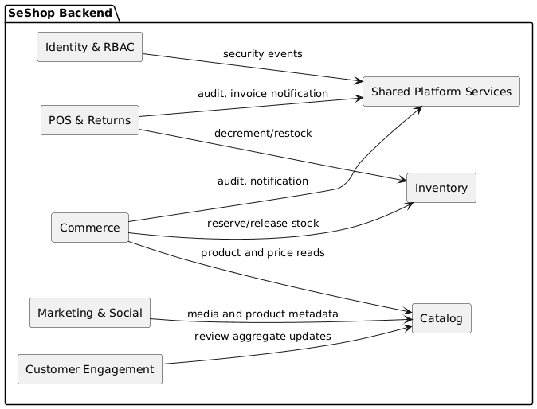
PlantUML Diagram

3.2 Implementation View
The implementation view maps logical modules to code organization. Each backend module follows a layered architecture (Controller, Service, Repository) to organize domain logic, web interactions, and database access.
com.seshop
├── identity/
│ ├── api/
│ ├── application/
│ ├── domain/
│ └── infrastructure/
├── catalog/
├── inventory/
├── commerce/
├── pos/
├── marketing/
├── engagement/
└── shared/
├── security/
├── audit/
├── exception/
├── config/
└── util/
Layer | Contents | Dependency Rule
api | Controllers, DTOs, request validation, HTTP mapping | Depends on application only.
application | Use cases, transactions, commands, queries, orchestration | Depends on domain ports and services.
domain | Entities, value objects, domain services, policies, port interfaces | No dependency on framework or persistence code.
infrastructure | JPA repositories, external clients, cache adapters, storage adapters | Implements interfaces defined by domain or application.
Dependency direction: api -> application -> domain <- infrastructure

3.3 Deployment View
SeShop deploys as a React SPA plus one or more stateless Spring Boot API instances backed by PostgreSQL, Redis, object storage, and approved external providers.
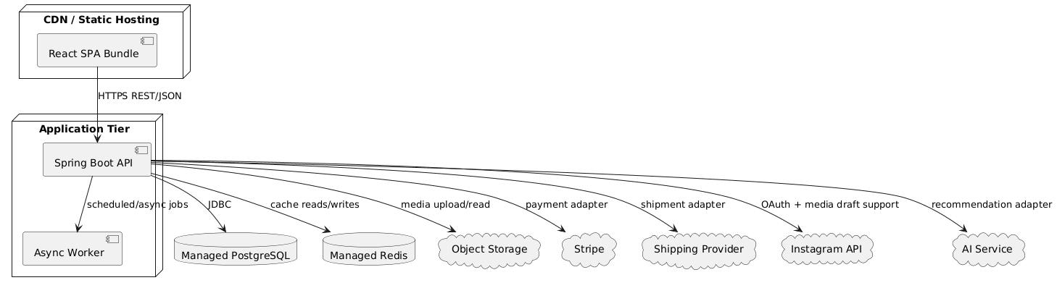
PlantUML Diagram
Environment | Purpose | Notes
Development | Local implementation and feature testing | Docker Compose may provide PostgreSQL and Redis.
Staging/UAT | Acceptance validation before release | Same architecture shape as production with controlled test data.
Production | Live customer and staff operation | Managed database/cache/storage, monitored API instances, reviewed migrations.

3.4 Data View
The data view is organized around table ownership. PostgreSQL is the source of truth, and each module owns a defined subset of tables.
Module | Owned Tables
Identity & RBAC | users, roles, permissions, role_permissions, user_roles, audit_logs
Catalog | categories, products, product_categories, product_variants, product_images
Inventory | locations, inventory_balances, inventory_transfers, inventory_transfer_items, cycle_counts, cycle_count_items, suppliers, purchase_orders, purchase_order_items, goods_receipts, goods_receipt_items
Commerce | carts, cart_items, orders, order_items, order_allocations, shipments, payments, discount_codes, discount_redemptions
POS & Returns | pos_shifts, pos_receipts, pos_receipt_items, cash_reconciliations, return_requests, return_items, refunds, exchanges, tax_invoices, invoice_adjustment_notes
Marketing & Social | instagram_connections, instagram_drafts
Customer Engagement | reviews
Data rules:
- Tables have one owning module.
- Cross-module reads and writes go through application services, not direct table access.
- Stock-affecting commands use transaction boundaries and row locks where required.
- Business identifiers such as orderNumber, skuCode, poNumber, and invoiceNumber are exposed for user-facing workflows while numeric IDs remain internal identifiers.
- Media files are stored in object storage; PostgreSQL stores metadata and URLs.

